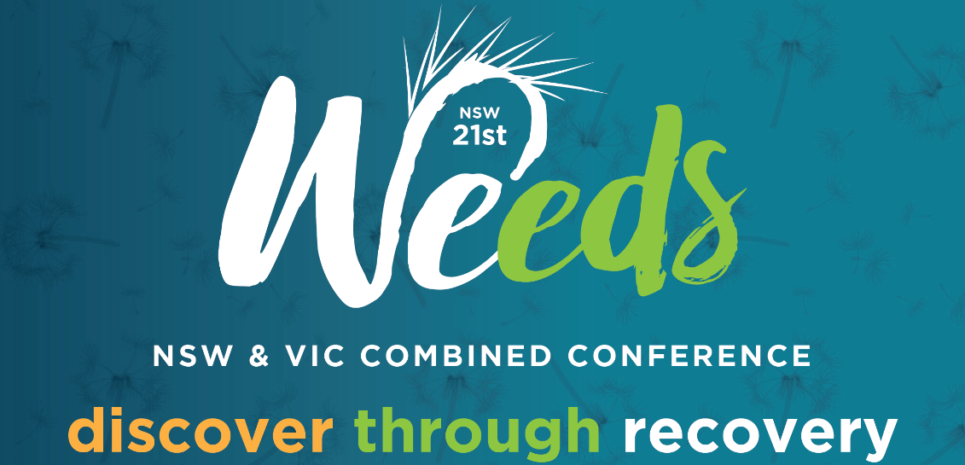

Submission are being invited for oral presentations and practical demonstrations at the NSW & VIC Combined Weeds Conference
Albury 23 -27 August 2021

Border closures, pandemic, drought, flood and fire have all challenged us through 2019 - 2020. What have we learnt during these challenging times? Topics to be discussed range from practical on-ground solutions and tools, the people that matter the most, latest weed science and research, policy and state border issues. All helping to protect our agricultural way of life, amenity and the environment from the impact of weeds. If you have a weed story, or something you want to demonstrate, we want to hear from you!

Conference sub-themes include (but not limited to):
- Engaging with the landholders – people matter!
- Impact of natural disasters on weeds, spread and management
- Using new enabling tools and technologies for weeds management
- Bridging borders (local, regional, state and national)

Please ensure you read the abstract guidelines below prior to submitting your abstract.
Submissions close 2pm ACST, Friday 26 February 2021.
Successful applicants will be advised by Friday 26 March 2021.
Abstract Submission Guidelines
- There is no limit to the number of abstracts that may be submitted by an individual.
- Submission acknowledges consent to print the abstract and contact details in the conference proceedings and list of presenting authors.
- The presenting author/demonstrator will be required to register for the conference and pay the required registration fee in order to ensure their abstract(s) or demonstration is included in the final programme. Deadline for presenting author registration will be advised in the acceptance letter.
- Abstracts are to be text only – limit of 300 words. Graphs, figures, diagrams, images etc. must not be included.
- Submissions should be completed electronically via the online submission form. If you are unable to submit in this manner, please contact the Conference Manager at bradley@ccem.com.au for further information.
- There is no guarantee that the submission of an abstract or request to provide a demonstration will lead to inclusion in the conference program and/or publication in the conference proceedings

