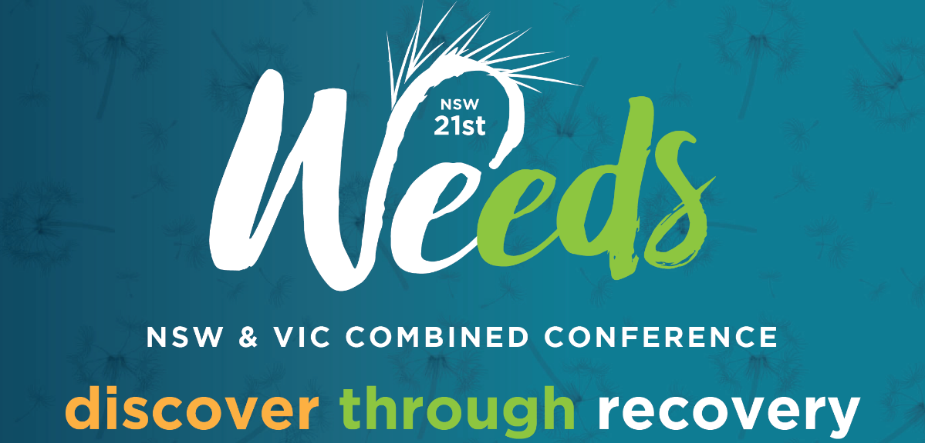
Presenters Expression of Interest Submission Form
This form is to be used to submit an expression of interest (abstract) to conduct an oral presentation or a practical demonstration at the 2021 NSW & VIC combined Weeds Conference to be held in Albury 24 – 26 August 2021.
Please ensure you have read the Presenters Guidelines and you have completed all relevant information before making this submission. If you are submitting multiple presentations and/or demonstrations please complete a separate form for each submission.
Completed submissions are to be emailed to: bradley@ccem.com.au by 2.00pm on Friday 26 February 2021.
Lead Author’s Name: Enter name here.
Lead Author’s Organisation: Enter organisation here.
Contact email: Enter email here.
Contact phone: Enter phone number here.
Names of any other authors to be recognised in proceedings:
Enter list of other authors to be recognised including organisation name. If none, please use N/A.
Names of any other authors who will be presenting at Conference:
Enter list of other presenting authors and their represented organisations. If none, please use N/A
Format of presentation:
Enter either ‘Oral Presentation’ or ‘Practical Demonstration’
Presentation Title (20 words):
Enter Presentation Title here
Abstract/Outline (300 words):
Abstract or outline here.
Photo (headshot) of authors included: Enter either: “Yes” or “No” (see guidelines).
Confirmation that all authors have given consent to the submission of this EOI: “Yes” or “No”.

